----------

URL : http://www.greenstechnologys.com/

NOTE: Take screenshot of homepage.

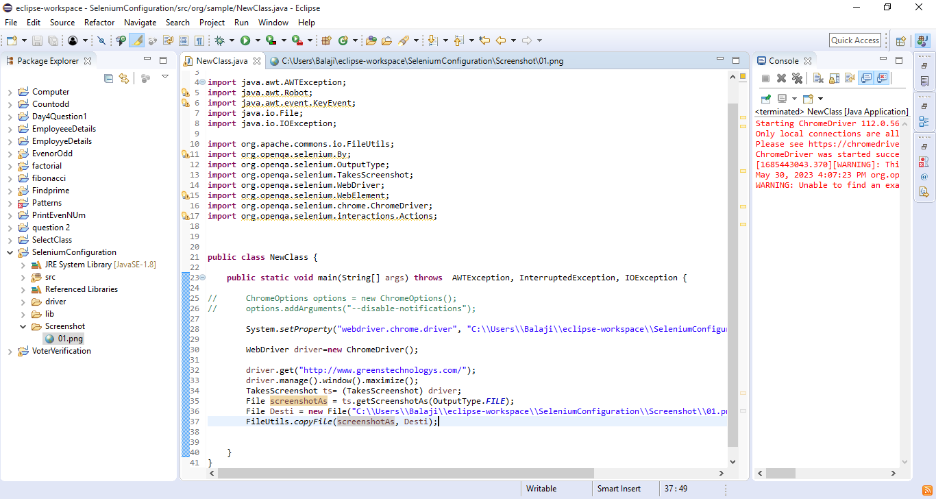

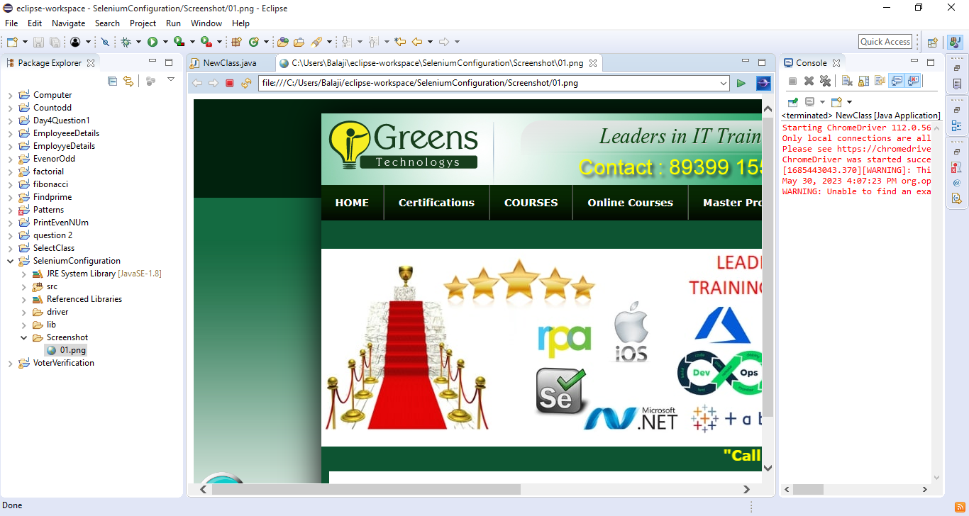

QUESTION 2

----------

URL : http://toolsqa.com/

NOTE: Scrolldown till "Recent Articles".

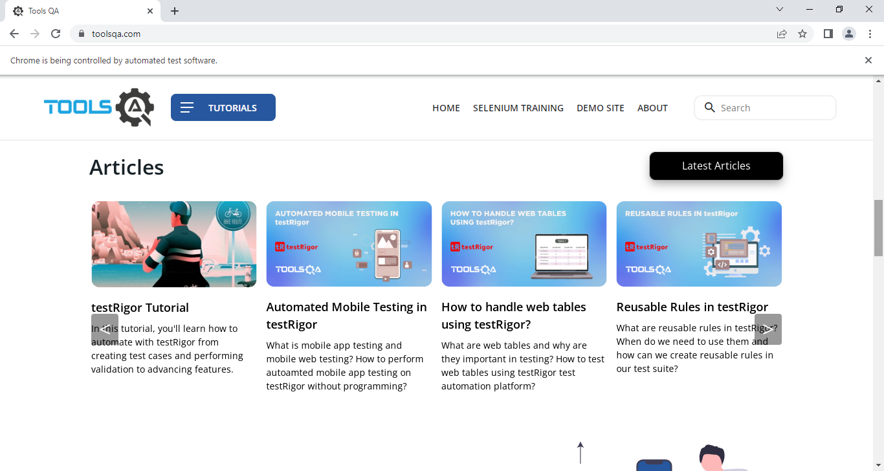

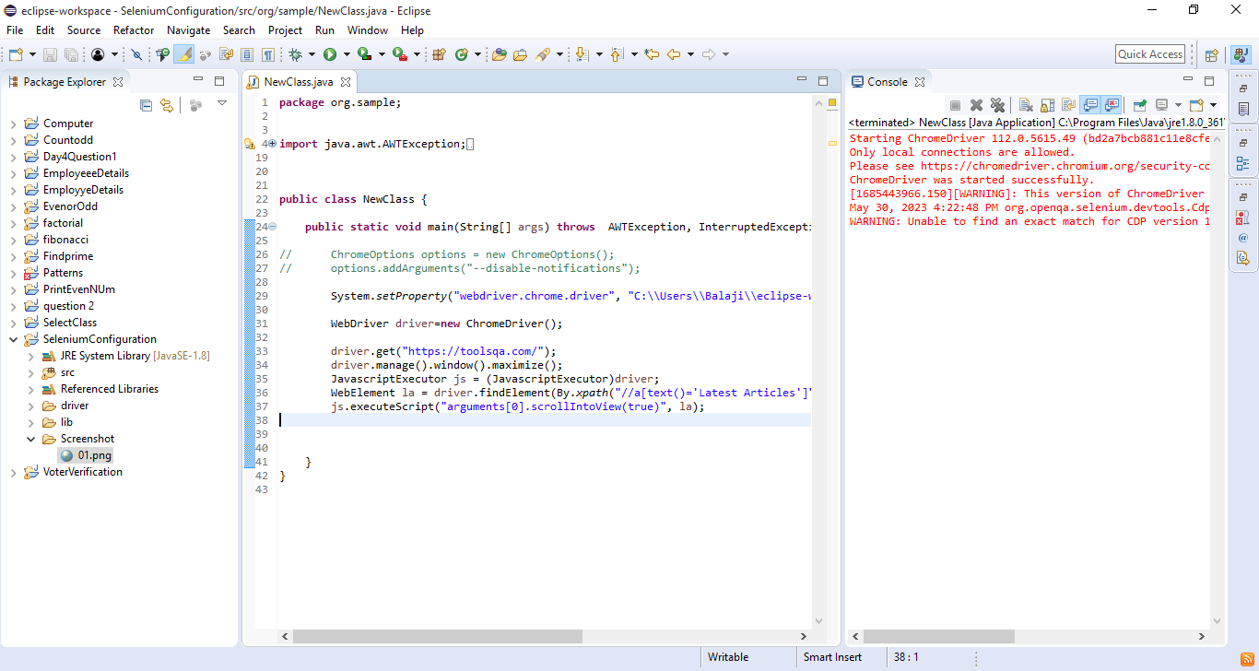

-----------

URL : http://toolsqa.com/

NOTE: Scrolldown till "Checkout what our Students say about us!" and print the word " Checkout what our Students say about us!"

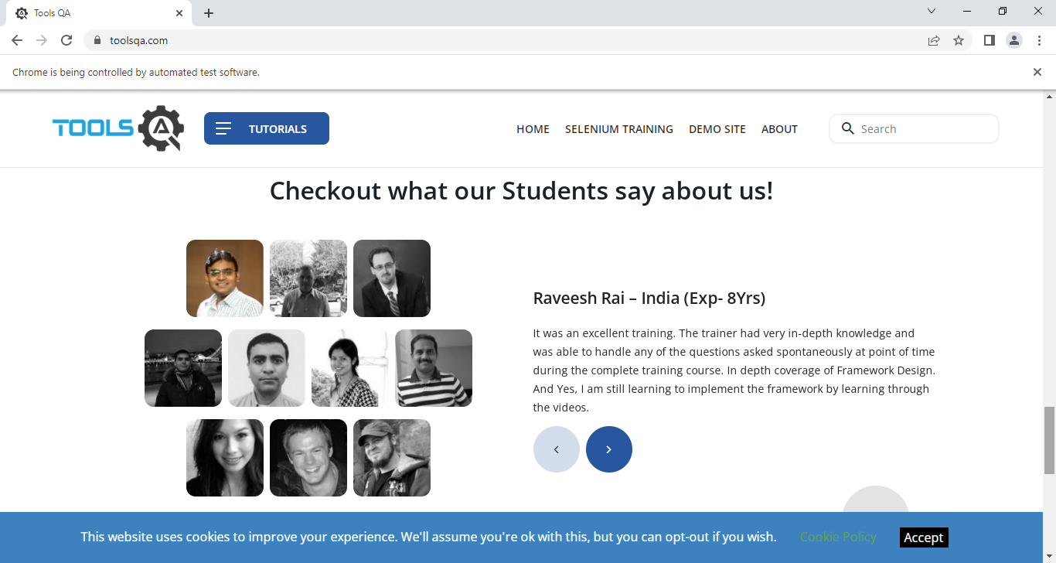

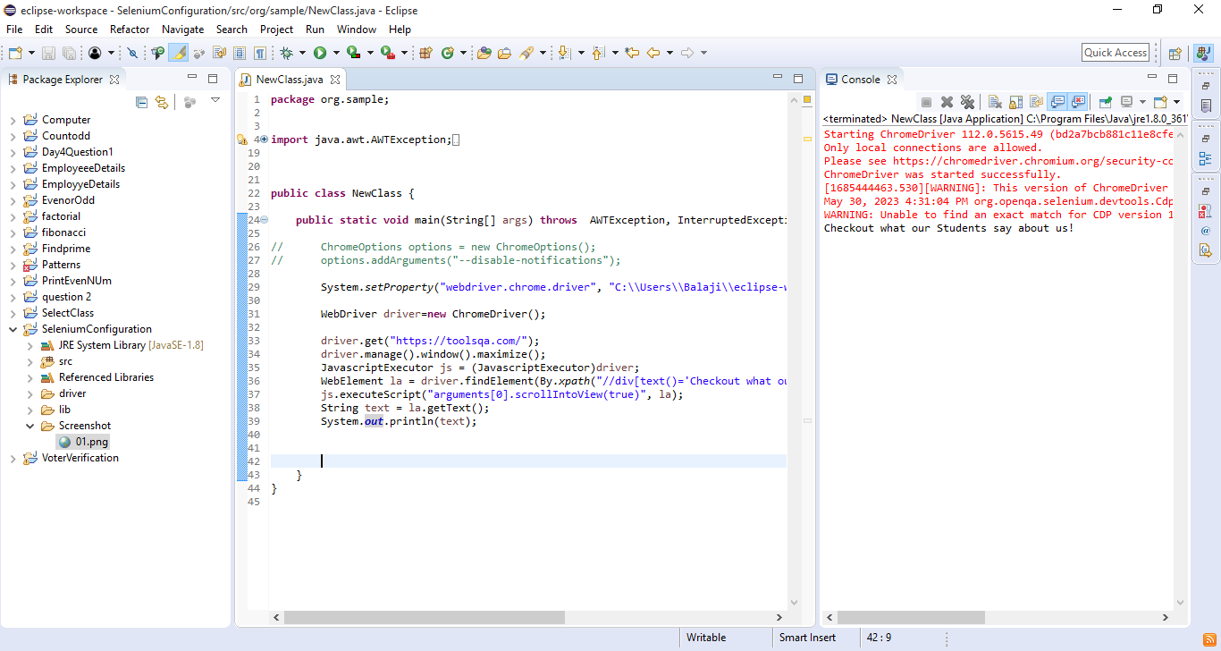

----------

URL : http://www.greenstechnologys.com/

NOTE: Scroll Down till "Greens technology Perumbakkam. address "and Take screenshot

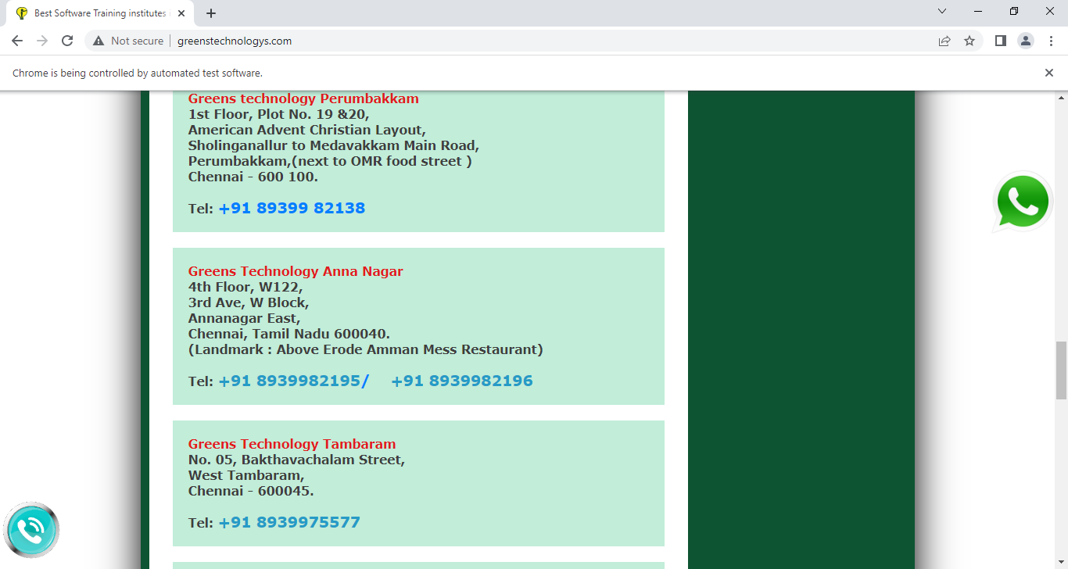

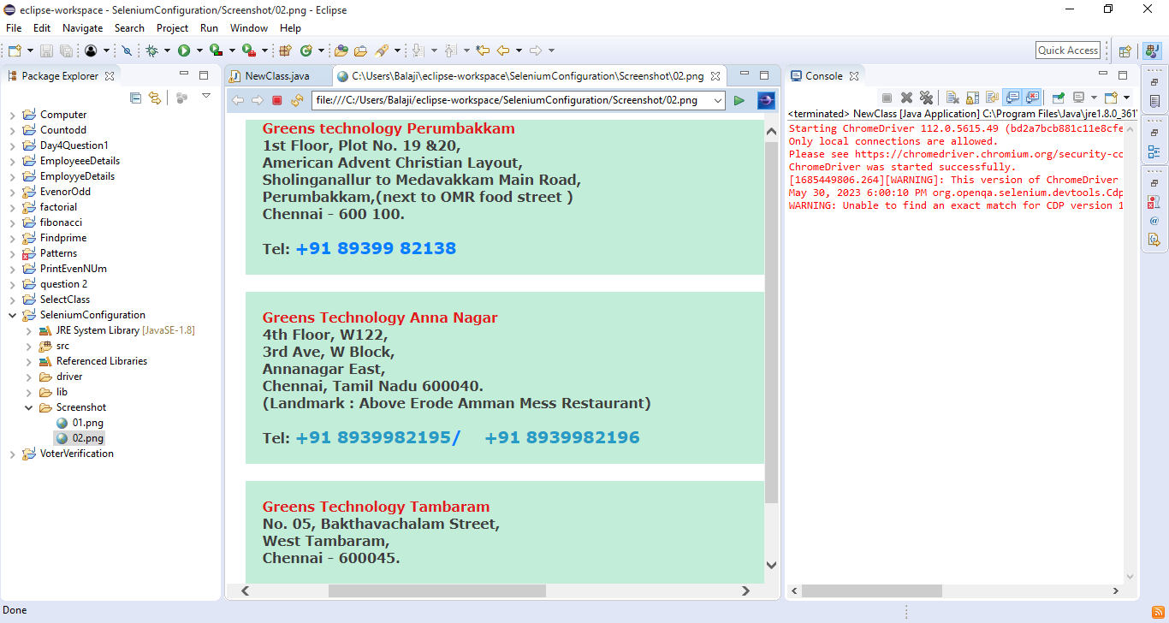 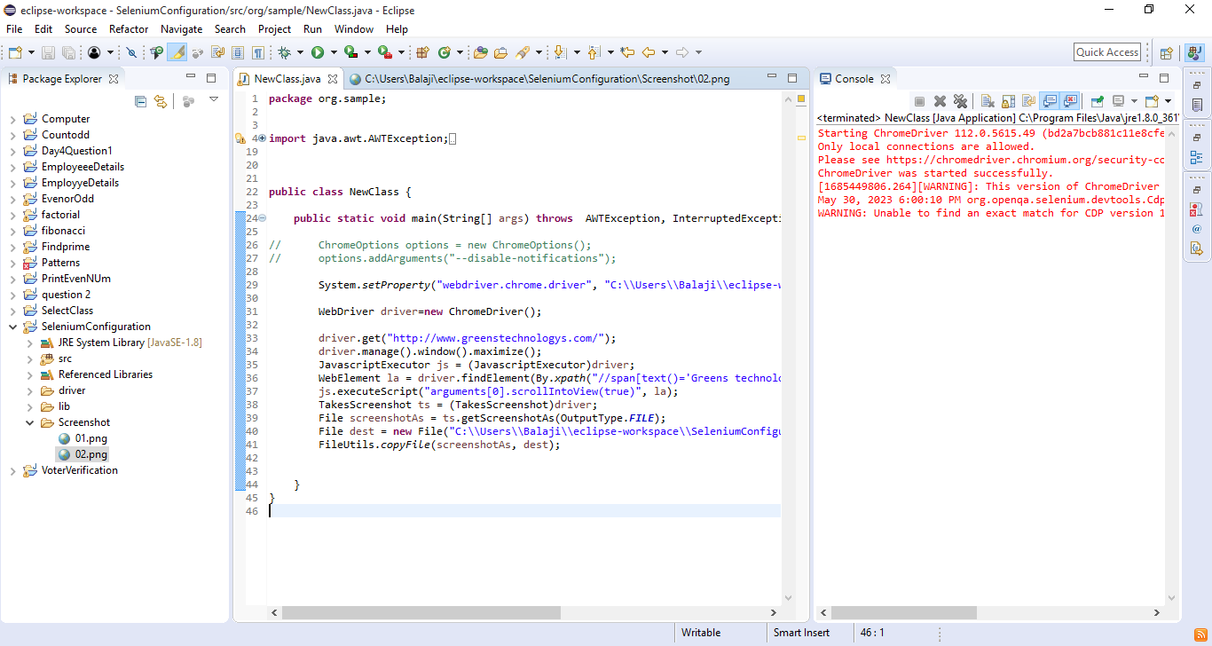

----------

URL : http://greenstech.in/selenium-course-content.html

NOTE: ScrollDown till "job opening" and Take the screenshot and scroll up Online Classroom

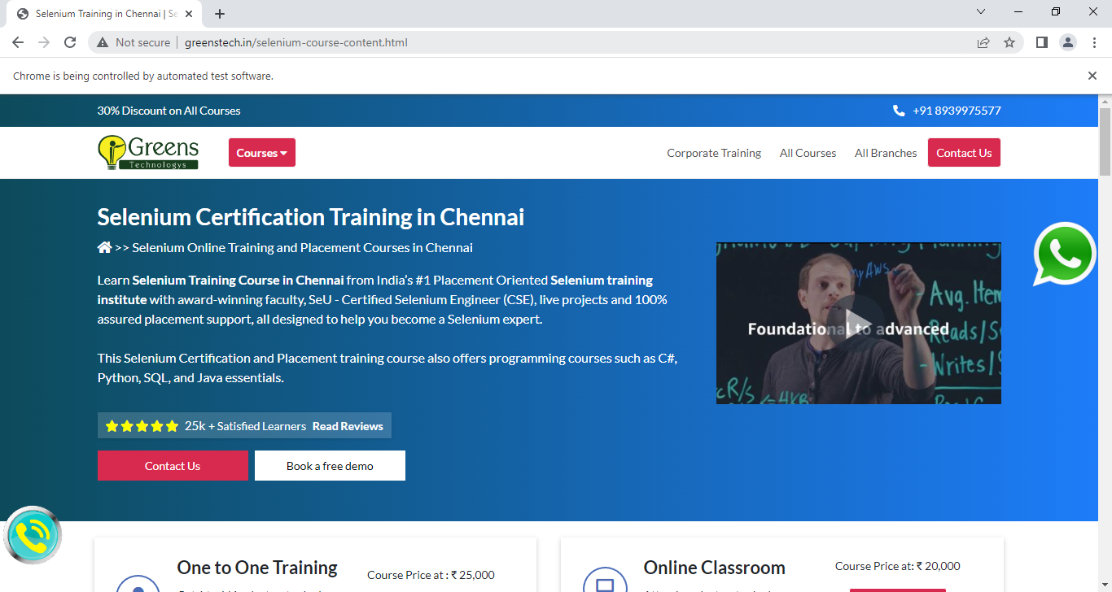

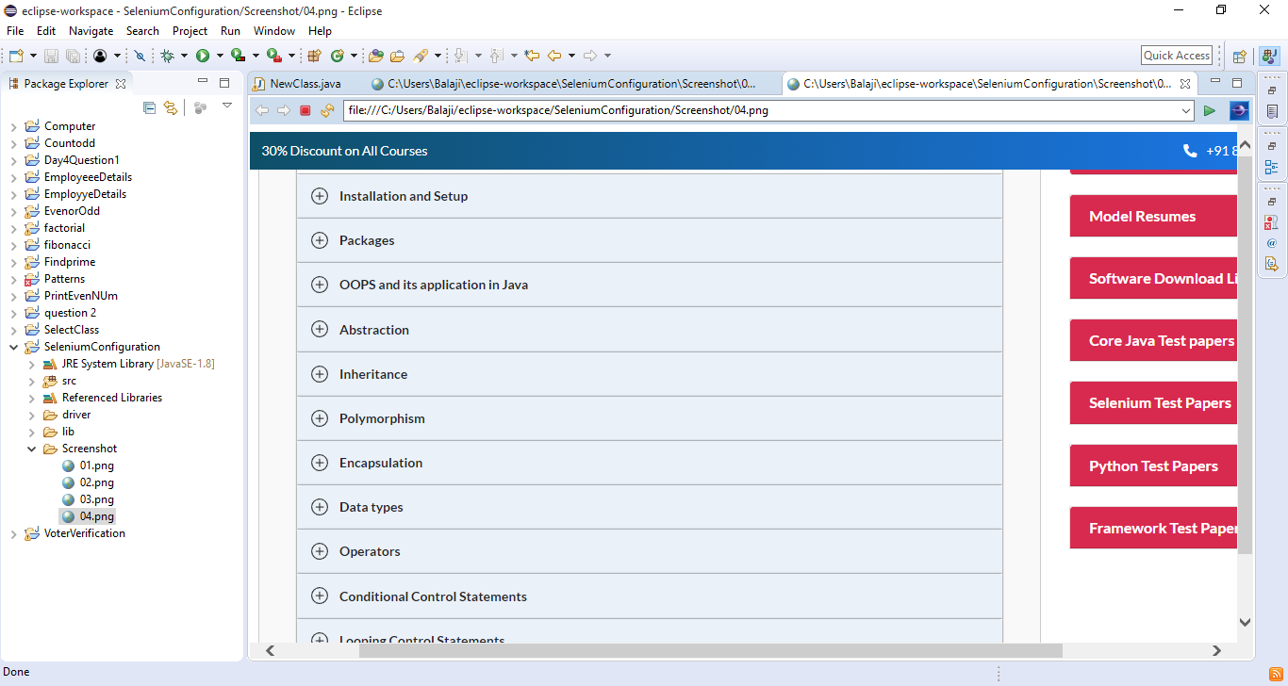

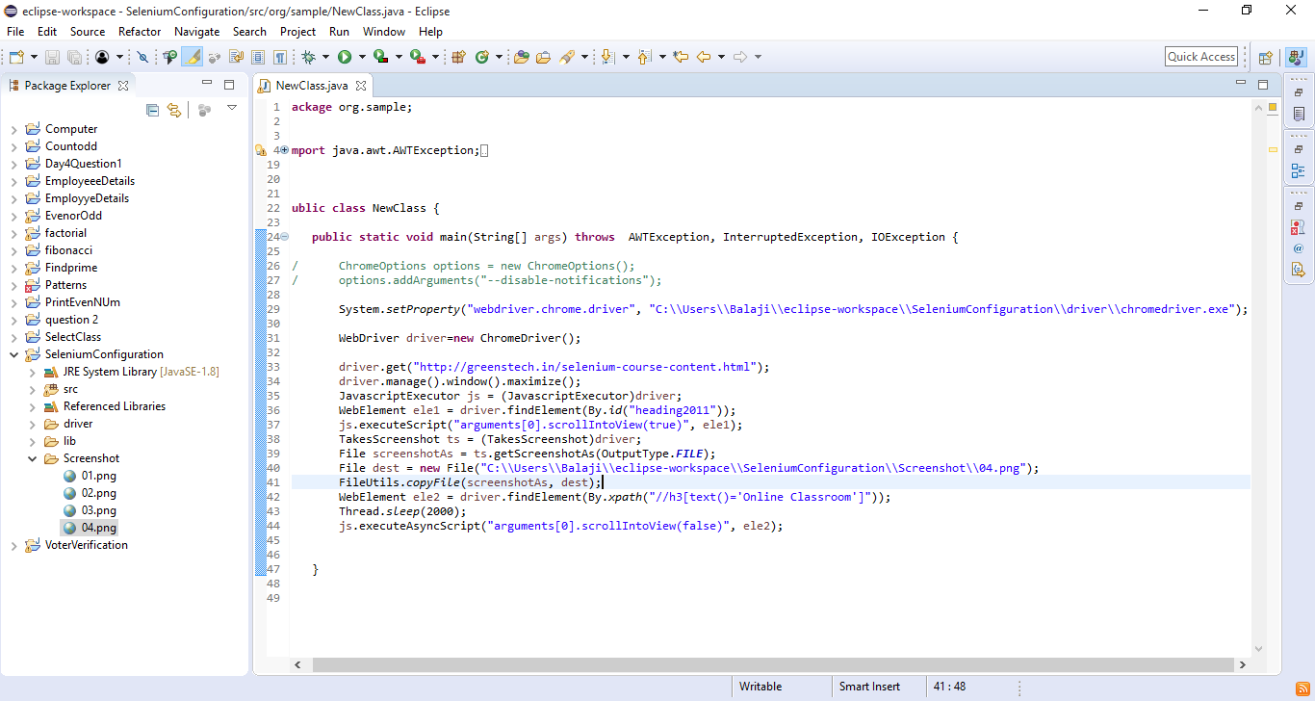

------------

URL : https://www.flipkart.com/

NOTE: Search iphone and take the screenshot.

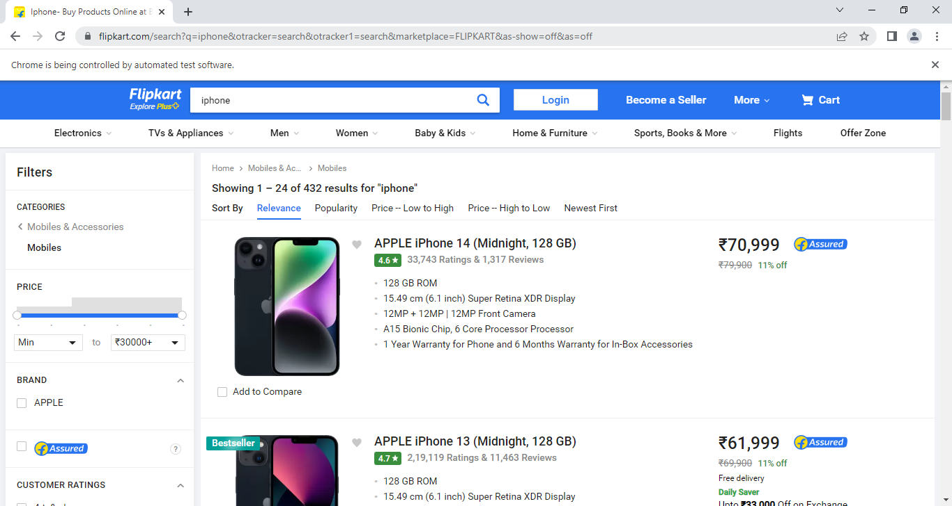

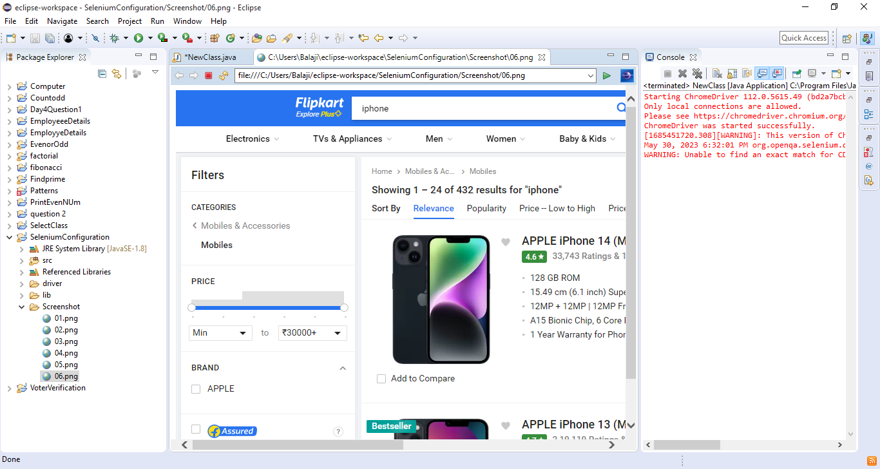

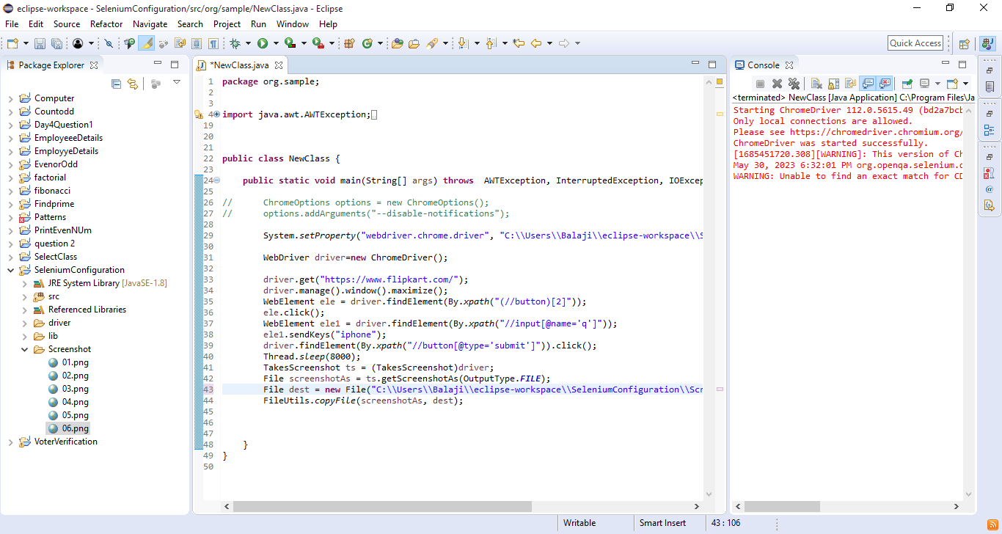

-----------

URL : https://www.amazon.in/

NOTE: Search motorolo and take the screenshot.

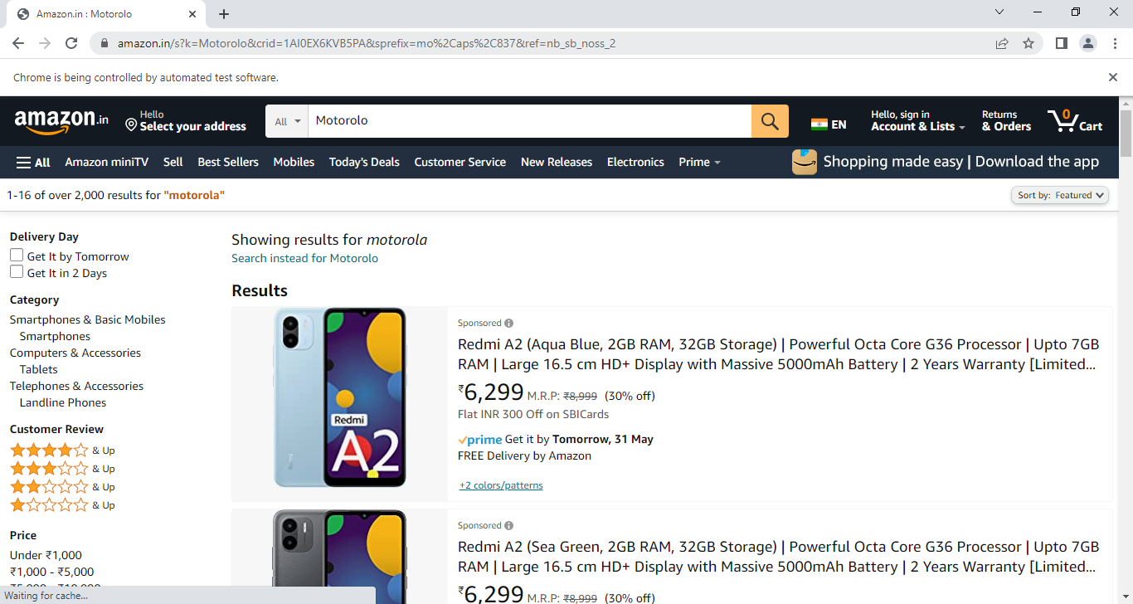

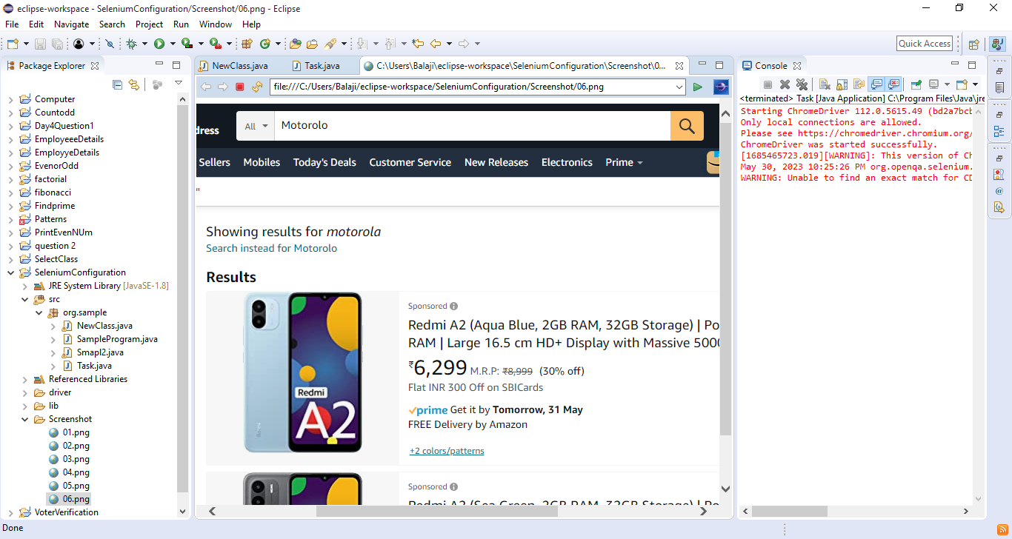

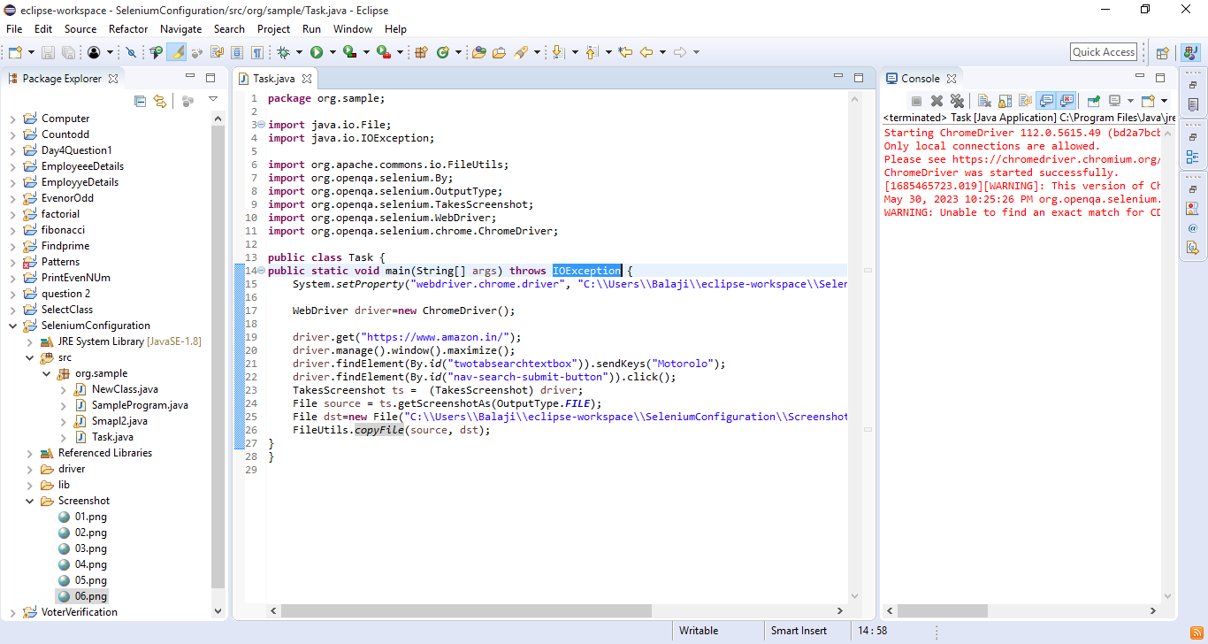

-----------

URL : https://www.snapdeal.com/

NOTE: search HP laptop and take the screenshot .

